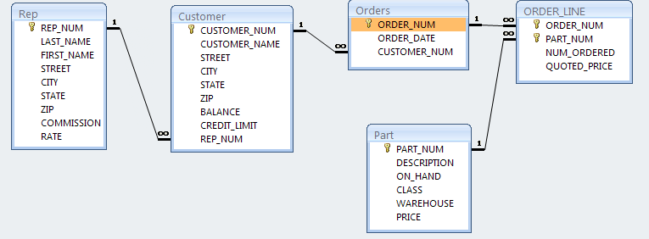

| **CUSTOMER** | | | | | | | | |
| --- | --- | --- | --- | --- | --- | --- | --- | --- |
| **CUSTOMER_NUM** | **CUSTOMER_NAME** | **STREET** | **CITY** | **STATE** | **ZIP** | **BALANCE** | **CREDIT_LIMIT** | **REP_NUM** |
| 148 | Al's Appliance and Sport | 2837 Greenway | Fillmore | FL | 33336 | $6,550.00 | $7,500.00 | 20 |
| 282 | Brookings Direct | 3827 Devon | Grove | FL | 33321 | $431.50 | $10,000.00 | 35 |
| 356 | Ferguson's | 382 Wildwood | Northfield | FL | 33146 | $5,785.00 | $7,500.00 | 65 |
| 408 | The Everything Shop | 1828 Raven | Crystal | FL | 33503 | $5,285.25 | $5,000.00 | 35 |
| 462 | Bargains Galore | 3829 Central | Grove | FL | 33321 | $3,412.00 | $10,000.00 | 65 |
| 524 | Kline's | 838 Ridgeland | Fillmore | FL | 33336 | $12,762.00 | $15,000.00 | 20 |
| 608 | Johnson's Department Store | 372 Oxford | Sheldon | FL | 33553 | $2,106.00 | $10,000.00 | 65 |
| 687 | Lee's Sport and Appliance | 282 Evergreen | Altonville | FL | 32543 | $2,851.00 | $5,000.00 | 35 |
| 725 | Deerfield's Four Seasons | 282 Columbia | Sheldon | FL | 33553 | $248.00 | $7,500.00 | 35 |
| 842 | All Season | 28 Lakeview | Grove | FL | 33321 | $8,221.00 | $7,500.00 | 20 |

| **ORDERS** | | |
| --- | --- | --- |
| **ORDER_NUM** | **ORDER_DATE** | **CUSTOMER_NUM** |
| 21608 | 10/20/2003 | 148 |
| 21610 | 10/20/2003 | 356 |
| 21613 | 10/21/2003 | 408 |
| 21614 | 10/21/2003 | 282 |
| 21617 | 10/23/2003 | 608 |
| 21619 | 10/23/2003 | 148 |
| 21623 | 10/23/2003 | 608 |

| **ORDER_LINE** | | | |
| --- | --- | --- | --- |
| **ORDER_NUM** | **PART_NUM** | **NUM_ORDERED** | **QUOTED_PRICE** |
| 21608 | AT94 | 11 | $21.95 |
| 21610 | DR93 | 1 | $495.00 |
| 21610 | DW11 | 1 | $399.99 |
| 21613 | KL62 | 4 | $329.95 |
| 21614 | KT03 | 2 | $595.00 |
| 21617 | BV06 | 2 | $794.95 |
| 21617 | CD52 | 4 | $150.00 |
| 21619 | DR93 | 1 | $495.00 |
| 21623 | KV29 | 2 | $1,290.00 |

| **PART** | | | | | |
| --- | --- | --- | --- | --- | --- |
| **PART_NUM** | **DESCRIPTION** | **ON_HAND** | **CLASS** | **WAREHOUSE** | **PRICE** |
| AT94 | Iron | 50 | HW | 3 | $24.95 |
| BV06 | Home Gym | 45 | SG | 2 | $794.95 |
| CD52 | Microwave Oven | 32 | AP | 1 | $165.00 |
| DL71 | Cordless Drill | 21 | HW | 3 | $129.95 |
| DR93 | Gas Range | 8 | AP | 2 | $495.00 |
| DW11 | Washer | 12 | AP | 3 | $399.99 |
| FD21 | Stand Mixer | 22 | HW | 3 | $159.95 |
| KL62 | Dryer | 12 | AP | 1 | $349.95 |
| KT03 | Dishwasher | 8 | AP | 3 | $595.00 |
| KV29 | Treadmill | 9 | SG | 2 | $1,390.00 |

| **REP** | | | | | | | | |
| --- | --- | --- | --- | --- | --- | --- | --- | --- |
| **REP_NUM** | **LAST_NAME** | **FIRST_NAME** | **STREET** | **CITY** | **STATE** | **ZIP** | **COMMISSION** | **RATE** |
| 20 | Kaiser | Valerie | 624 Randall | Grove | FL | 33321 | $20,542.50 | 0.05 |
| 35 | Hull | Richard | 532 Jackson | Sheldon | FL | 33553 | $39,216.00 | 0.07 |
| 65 | Perez | Juan | 1626 Taylor | Fillmore | FL | 33336 | $23,487.00 | 0.05 |